Process Flow
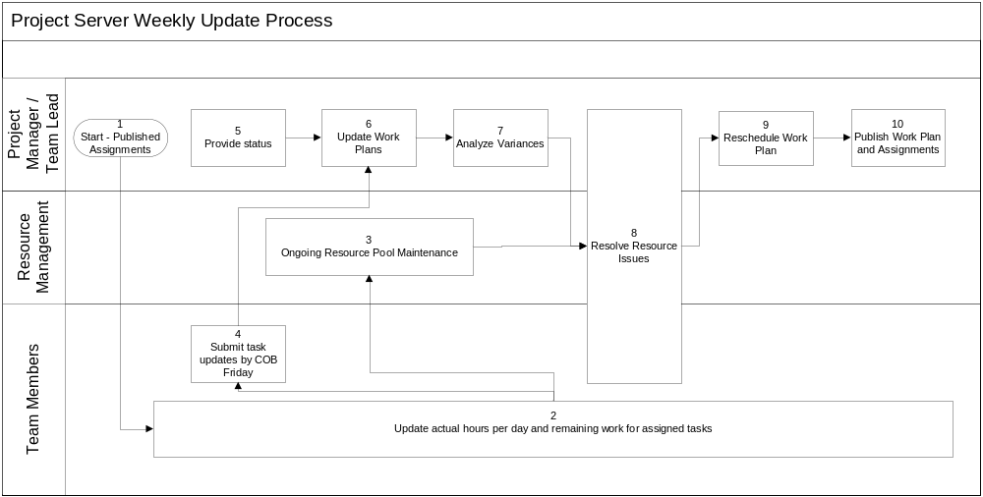

Operating Procedure
- Start – Published Assignments and Work Plan
The appropriate Project Manager / Team Lead and Resource Managers have agreed tasks, estimates and dependencies for delivery of defined work products, and the Project Manager / Team Lead has published both schedule and task assignments.
Refer to MK PMO SharePoint site for standard project manager training documentation detailing publishing work plans and assignments

- Update Actual Hours and Remaining Work
Team Members use Project Web Access to update actual hours (by day) spent on assigned tasks and adjust their remaining work as appropriate to account for variances from the original estimates.
Refer to Project Web Access Home Page for standard team member training documentation detailing updating actual hours and work remaining (web-based training is also available for this topic)

- Resource Pool Maintenance
Resource Managers maintain Enterprise Resource Pool information (additions, deletions and adjustments) and update individual resource calendars to reflect true availability.
Refer to Project Web Access Home Page for resource manager training documentation detailing enterprise resource pool maintenance

- Submit Task Updates for Week
Team Members submit their task updates for approval no later than close of business every Friday (first thing Monday at the absolute latest).
Refer to Project Web Access Home Page for standard team member training documentation detailing update submissions

- Provide Status
The Project Manager / Team Lead provides the Release Manager updated status by 10:00 am Monday, highlighting key accomplishments, current risks and issues, and plans for week ahead.

- Update Work Plan with Actual Hours and Adjusted Remaining Work
The Project Manager / Team Lead reviews updates submitted by Team Members, resolves issues and applies updates to the work plan. This should be completed by no later than Monday noon.
Refer to MK PMO SharePoint site for standard project manager training documentation for applying team member updates

- Analyze Variances
The Project Manager / Team Lead works with relevant resources to identify, analyze and understand variances of planned delivery of work products. Actionable steps are defined and implemented to resolve identified variances from plan.

- Resolve Resource Issues
The Project Manager / Team Lead works with appropriate Resource Managers to resolve any resource over allocation issues.
- Reschedule Work Plan
The Project Manager / Team Lead updates the project status date to reflect the end of the previous week, and reschedules any uncompleted work to start after the current status date. This should also take place no later end of day Monday.
- Publish Work Plan and Assignments
The Project Manager / Team Lead publishes the work plan and any updated assignments no later than noon on Tuesday.
Refer to MK PMO SharePoint site for standard project manager training documentation for publishing project plans and assignments

